MORENO VALLEY DISCIPLES
OPEN BOOK
PAMPHLET

INDEX

INTRODUCTION…………………3
EXPENSES……………………….4-8
FUTURE…………………………..9

INTRODUCTION

HELLO EVERYONE AND THANK YOU FOR PARTICIPATING IN OUR FALL 2022 SEASON! WE ARE HAPPY YOU CHOSE US TO GROW WITH FOR THIS SEASON! IT IS OUR SECOND YEAR AS AN ORGANIZATION, AND FIRST YEAR AS A COMPLETE CHAPTER. WE THANK YOU FOR YOUR PATIENTS, SUPPORT, AND DEDICATION. WE HOPE THAT YOU AND YOUR CHILD ARE ENJOYING YOUR TIME HERE WITH THE PROGRAM.

OUR MOTTO IS FAITH, FAMILY, & FOOTBALL!
WE WILL NEVER CLAIM TO BE PERFECT, BUT WE ARE ALL STRIVING TO BE BETTER. WE WANT TO CHALLENGE EACH OF OUR YOUTH TO BE THEIR VERY BEST. OUR GOAL IS TO INSTILL IN OUR ATHLETE’S THE 3D’S: DISCIPLINE, DEDICATION, AND DETERMINATION. THE 3DS ARE IMPORTANT TO ANYONE TRYING TO ACCOMPLISH INDIVIDUAL GOALS. WE ENCOURAGE OUR YOUTH TO BE DISCIPLINED, DEDICATED, AND DETERMINED IN THEIR FAITH, EDUCATION, SPORT, AND DEVELOPMENT.

WE RESIDE IN MORENO VALLEY, AND OUR GOAL IS TO HELP PUSH, GROOM, AND GROW TALENT IN THE CITY TO HELP HIGHLIGHT AND BRING ATTENTION TO MORENO VALLEY. OUR ATHLETES SHOULD NOT HAVE TO LEAVE THE CITY IN HOPES OF GETTING GOOD QUALITY AND FAIRNESS IN WITH FOOTBALL. SO, WE THANK YOU FOR YOUR HELP AND SUPPORT OF TRYING TO BUILD A PROGRAM THAT SUPPORTS THE YOUTH AND CITY OF MORENO VALLEY!

FOOTBALL EXPENSES

Supreme
……………………………………$3,500.00
Uniforms
……………………………………$13,000.00
Practice Field (Monthly Bill) ……………………………….......$5,303.00 (To Date)
Game Day
……………………………………$9,360.00
Equipment
……………………………………$20,180.00
Website Build
……………………………………$499.00
Social Media Web Page Update (Monthly)
……………………………........ $798.00 (To Date)
Cheer Uniforms
……………………………………$4912.00

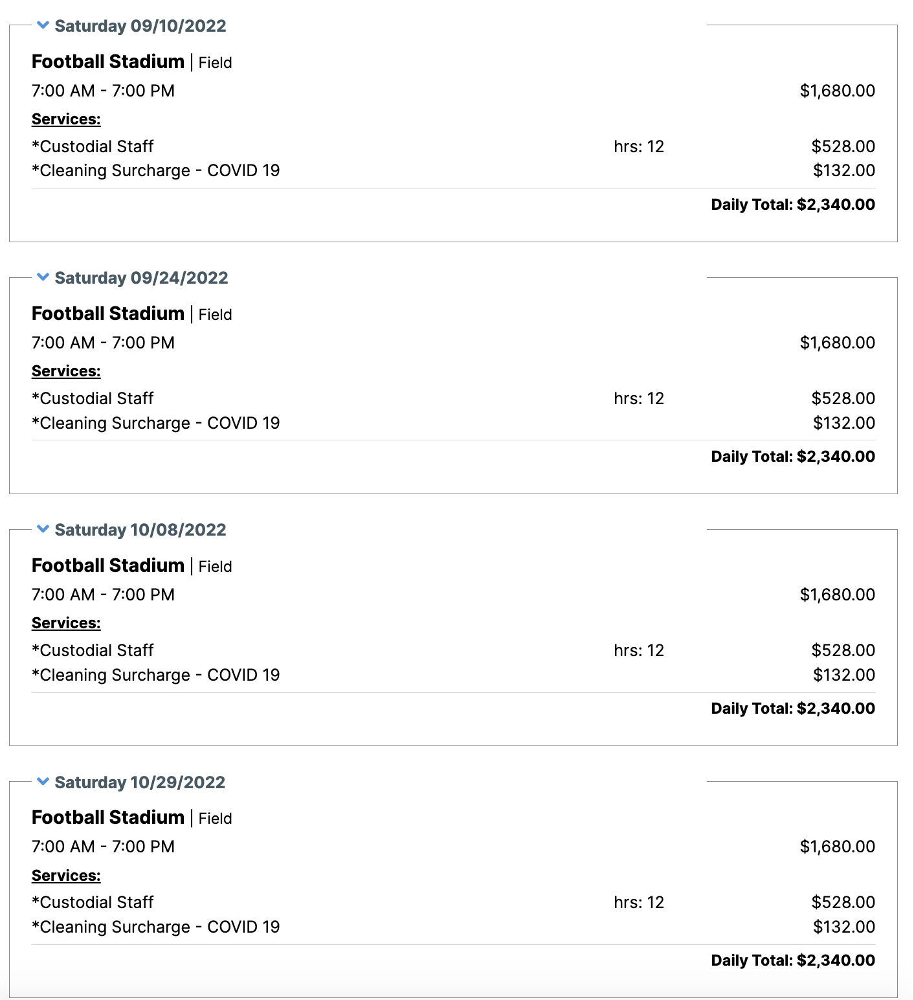
HOME GAME RECEIPTS

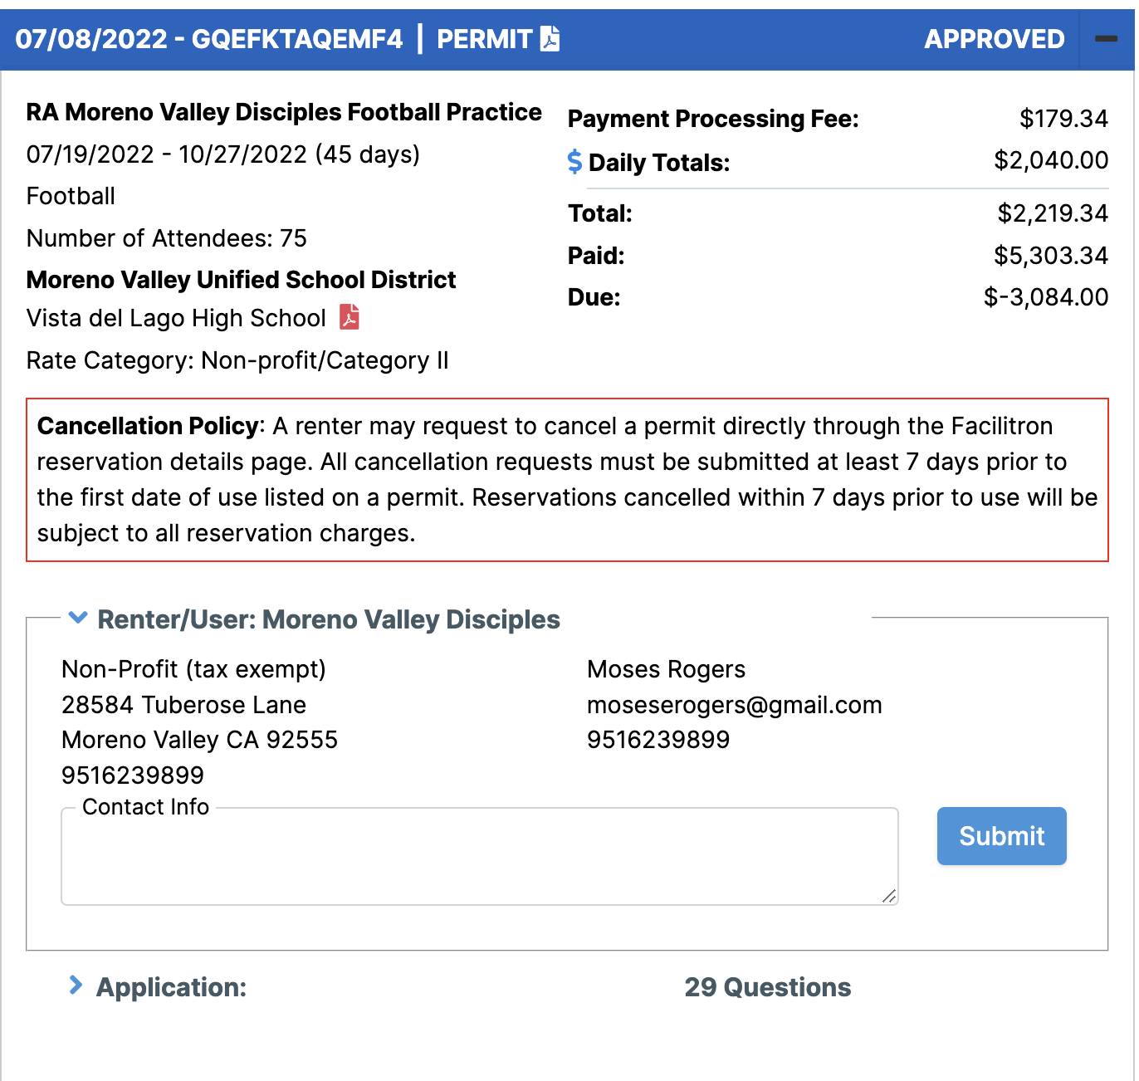
PRACTICE FIELD

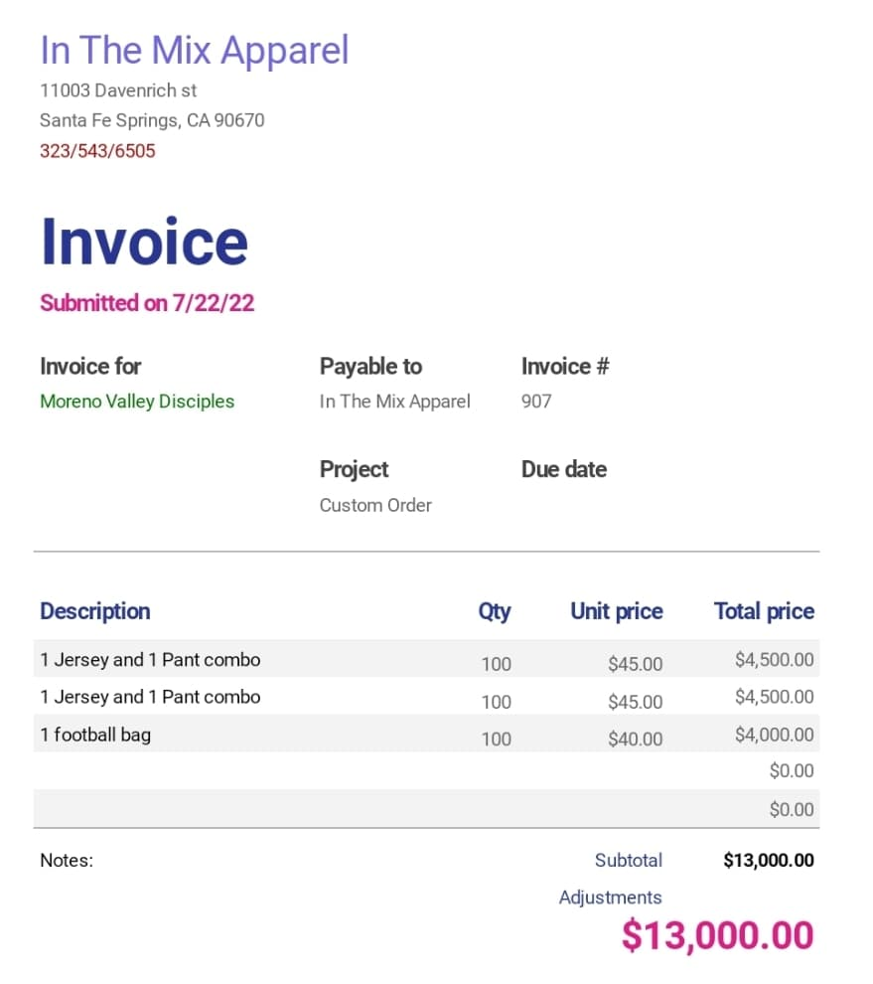
UNIFORMS

EQUPIMENT
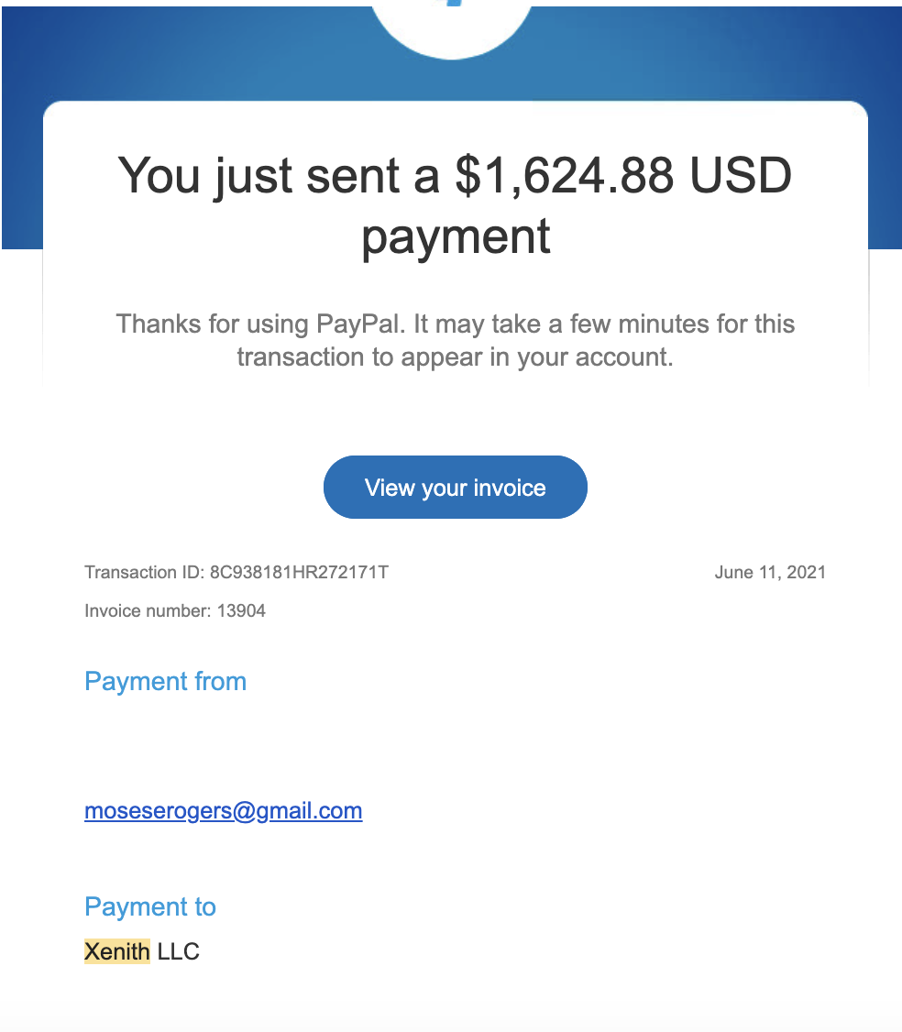
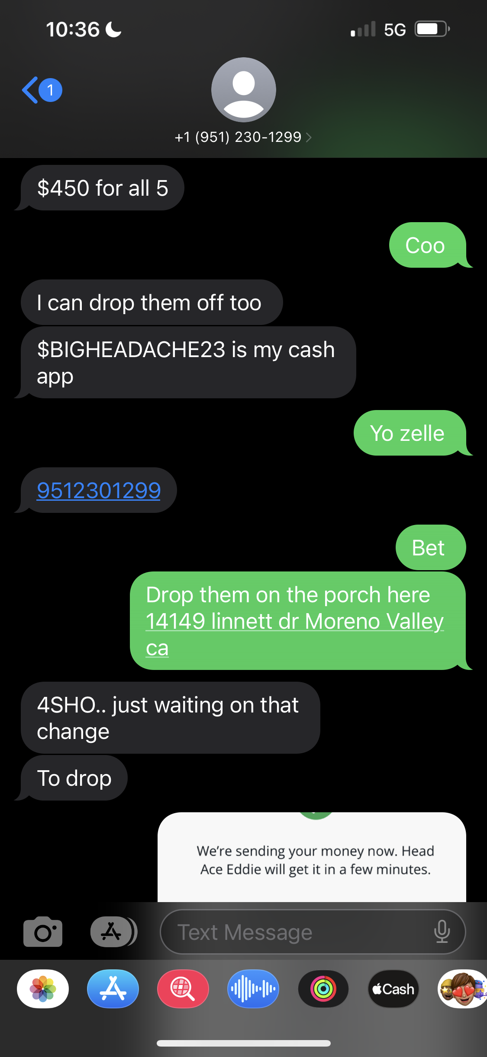
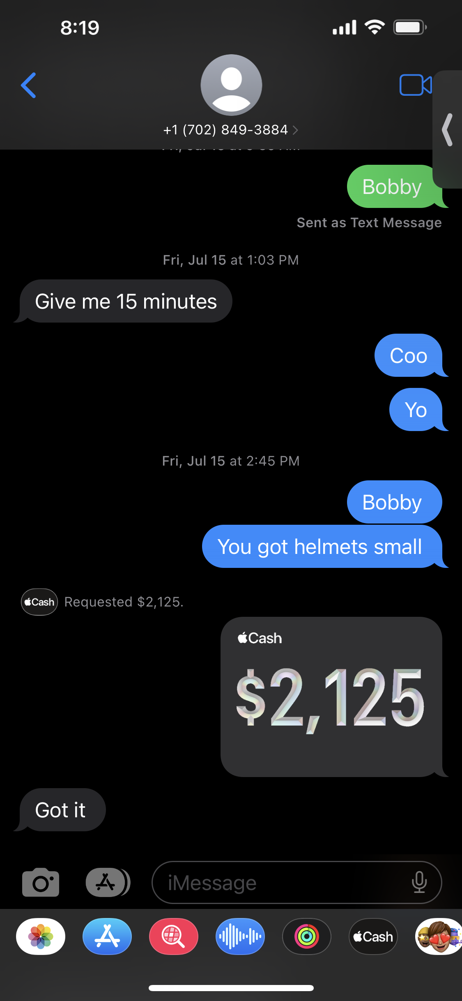
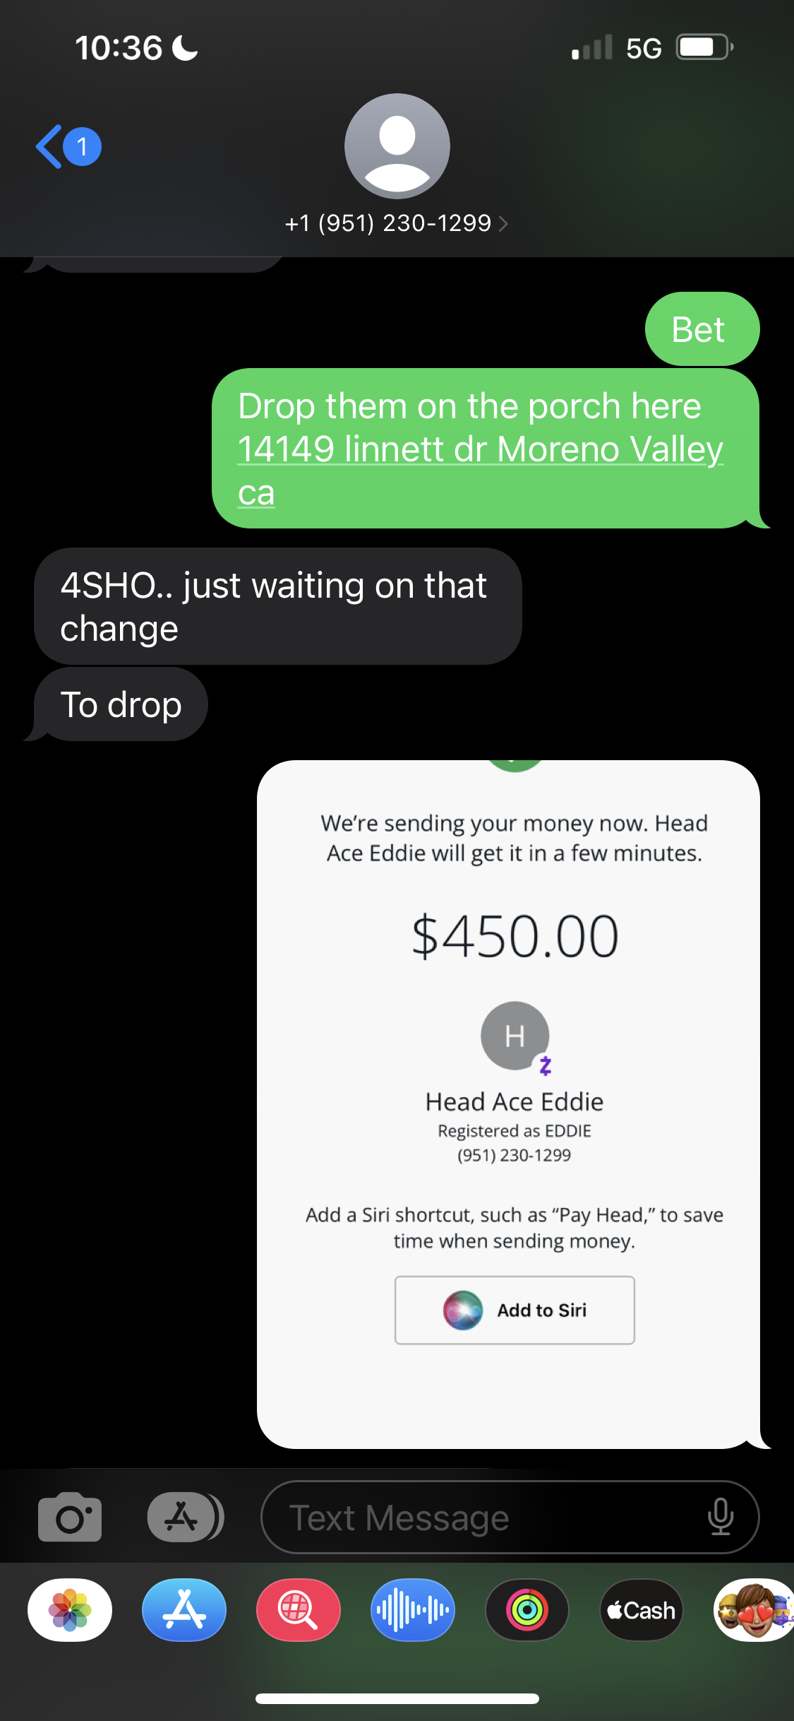
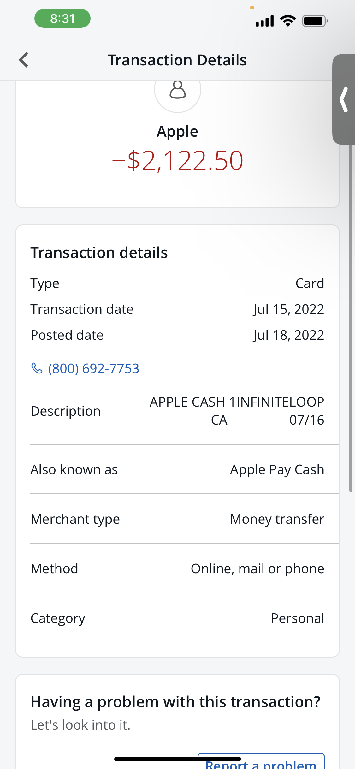

VALLEY LIFE SPORT COMPLEX

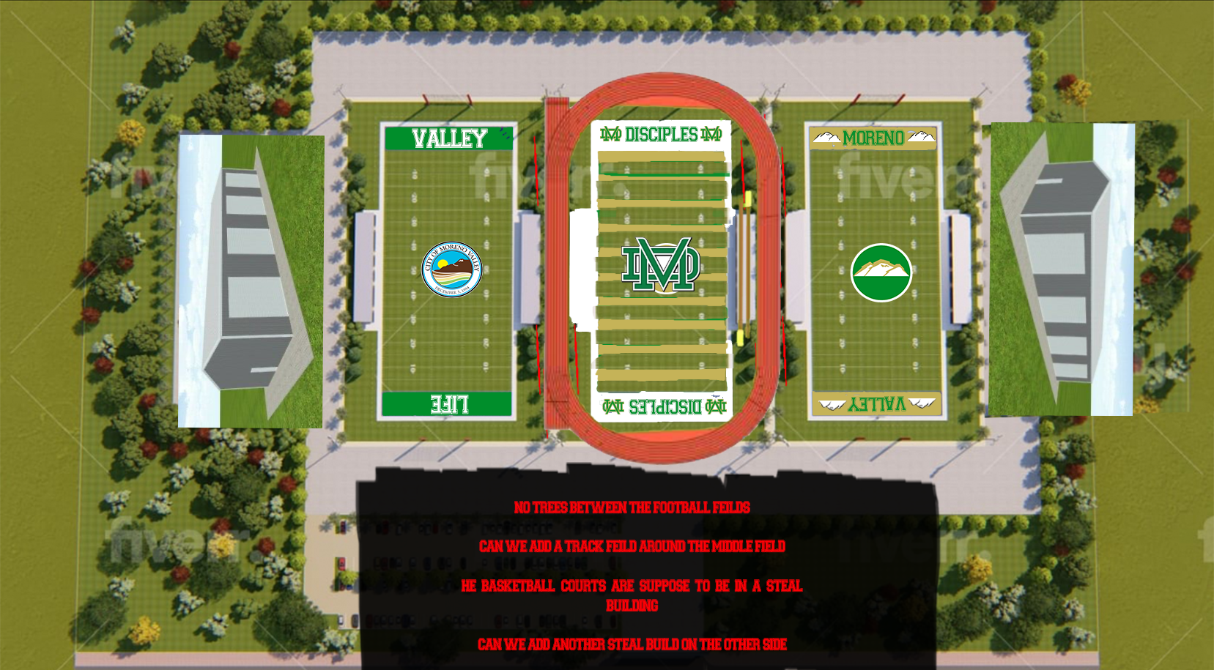
OUR GOAL IS TO BUILD A PRIVATE SPORTS COMPLEX FOR THE CITY OF MORENO VALLEY. IT IS OUR DESIRE TO SERVICE OUR CITY IN MANY DIFFERENT WAYS. WE REALIZE CHANGE STARTS WITH THE YOUTH, SO WE ARE DEDICATED TO FOCUSING ON THEM. THIS FACILITY WILL NOT ONLY HAVE FOOTBALL, BUT BASKETBALL, BASEBALL, AND TRACK. PROVIDING OTHER SPORT TRAINING ALONG WITH EDUCATION COULD AND WOULD HAPPEN AT THIS FACILITY. IT IS OUR MISSION TO HAVE THE FIELD BUILT BY 2024. OUR PURSUITE IS TO MAKE THE FIELD COMPLETELY SOLAR POWERED. WITH YOUR HELP AND SUPPORT, OUR CHILDREN WILL BE ABLE TO SAY THAT IS THEIR FIELD…AND MEAN IT!

